**java_springboot_restful_28_AlbumController – Build Photo Upload for Album**

**In AlbumController.java -> photos method -> Updated like below**

 @PostMapping(value = "{album_id}/upload_photos", consumes = { "multipart/form-data" })

    @Operation(summary = "Upload Photo into album")

    @SecurityRequirement(name = "studyeasy-demo-api")

    @ApiResponse(responseCode = "400", description = "Please check the payload of token")

    public ResponseEntity<List<String>> photos(@RequestPart(required = true) MultipartFile[] files,

            @PathVariable long album_id, Authentication authentication) {

        String email = authentication.getName();

        Optional<Account> optionalAccount = accountService.findByEmail(email);

        Account account = optionalAccount.get();

        Optional<Album> optionalAlbum = albumService.findById(album_id);

        Album album;

        if (optionalAlbum.isPresent()) {

            album = optionalAlbum.get();

            if (account.getId() != album.getAccount().getId()) {

                return ResponseEntity.status(HttpStatus.BAD_GATEWAY).body(null);

            }

        } else {

            return ResponseEntity.status(HttpStatus.BAD_GATEWAY).body(null);

        }

        List<String> fileNamesWithSuccess = new ArrayList<>();

        List<String> fileNamesWithError = new ArrayList<>();

        Arrays.asList(files).stream().forEach(file -> {

            //Checking the type of the file is correct or not

            String contentType = file.getContentType();

            if(contentType.equals("image/png")

            || contentType.equals("image/jpg")

            || contentType.equals("image/jpeg")){

                fileNamesWithSuccess.add(file.getOriginalFilename());

                // When we are storing the file in the database, there is a possibility that file name from the user

                // is repeating and if that happens, then file from the user will get repeated and in server will

                // get replaced.

                // In order to prevent that, we need to create a random string.;

                int length = 10;

                boolean useLetters = true;

                boolean useNumbers = true;

                try {

                    String fileName = file.getOriginalFilename();

                    String generatedString = RandomStringUtils.random(length, useLetters, useNumbers);

                    String final_photo_name = generatedString + fileName;

                    String absolute_fileLocation = AppUtil.get_photo_upload_path(final_photo_name, album_id);

                    Path path = Paths.get(absolute_fileLocation);

                    Files.copy(file.getInputStream(), path, StandardCopyOption.REPLACE_EXISTING);

                } catch (Exception e) {

                    // TODO: handle exception

                }

            }

        });

        return null;

    }

**Add below code in AlbumService.java**

public Optional<Album> findById(long id){

        return albumRepository.findById(id);

    }

**Create a util -> AppUtils -> Inside that create file -> AppUtil.java**

package org.studyeasy.SpringRestdemo.util.AppUtils;

import java.io.File;

import java.io.IOException;

import java.nio.file.Files;

import java.nio.file.Paths;

//Receiving the filename and also the album_id

public class AppUtil {

    public static String get_photo_upload_path(String fileName, long album_id) throws IOException {

        Files.createDirectories(Paths.get("src\\main\\resources\\static\\uploads\\" + album_id));

        return new File("src\\main\\resources\\static\\uploads\\" + album_id).getAbsolutePath() + "\\" + fileName;

    }

}

**Output**

**When you try to upload the photo with an invalid id like 100, you get 500 error**

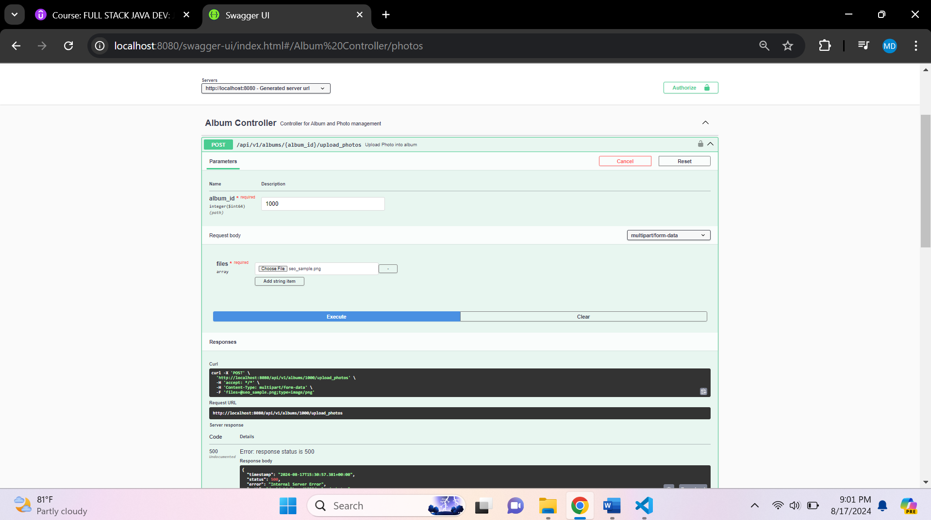

**And you also get error in console like below**

# java.lang.NullPointerException: Cannot invoke "org.springframework.security.core.Authentication.getName()" because "authentication" is null

**Add Album**

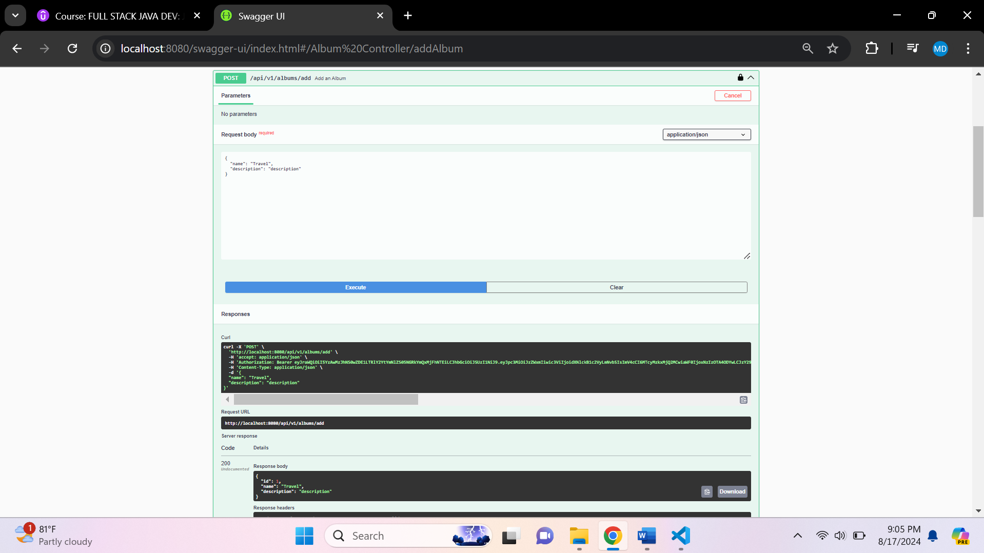

**The id is 1 and use it in Api for uploading folders**

**The next output is in the pdf form**